MySQL - Helpdesk Guide
Data Engineering

Instructions
For this assignment, you will use MySQL to set up a database from two tables. Then, you will write SQL queries to complete a series of tasks related to the company’s helpdesk ticketing system.
You should submit your work to Canvas in a single PDF submission. Include screenshots from each query. Your screenshot should include 1) the script, 2) a sample of the output, and 3) the total number of records returned from the output screen. Your file should be named “YourName_M3Helpdesk”.

Background
The first table you’ll use is the employee table, which contains the employee’s ID as the primary key, first name, last name, and location. You can assume all employees at the company are listed here.
The second table you’ll use is the ticket table, which contains each individual helpdesk ticket. The ticket table contains the ticket ID as the primary key, a description of the helpdesk incident, the duration in minutes, a priority, a status, and which employee (if any) has been assigned to the ticket. If no one is available, a ticket will be logged into the system in this table, but no employee will be assigned yet.
The incident status can be completed, in progress, or not started.
- If an incident is completed, the duration field will contain the number of minutes the incident took, and the employee ID will reference the employee who completed the service.
- If an incident is in progress, the duration field number denotes the number of minutes since the incident started, and the employee ID will reference the employee who is currently working on the service (assume for now that all incidents will be completely serviced by the single employee who is assigned to them).
- If an incident service is not yet started, the duration field will be blank, and there will not be an employee assigned to that incident, either.

Part 1: Setting Up the Database
Use the following steps to set up the database.
- Launch Workbench in MySQL.
- Download the “Helpdesk_setup.sql” script and run it.
- Here is the Entity Relationship diagram:
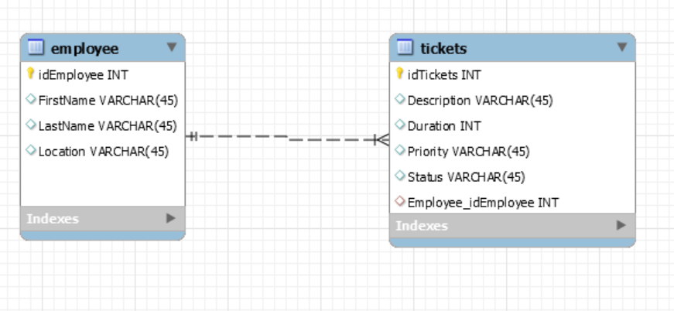
Figure 1: Employee and ticket relationship diagram

- Download and run the “Helpdesk_insert.sql” script to insert data into the helpdesk database.
- Run the following counts to verify your helpdesk database is up and running properly:
  - SELECT COUNT(*) from helpdesk.employee; (Should be 7 records)
  - SELECT COUNT(*) from helpdesk.tickets; (Should be 30 records)

Part 2: Writing SQL Queries
Write SQL queries to complete the following tasks that the company has asked for:
- Select the first name, last name, ticket ID, ticket description, and duration of the employees who are assigned to a ticket(s). Sort them first alphabetically by first name (starting with letter A at the top) and then ascending by duration.
- We want to get the workload by employee. For every employee, select the first name, last name, all ticket ID numbers assigned to that employee, the ticket description, and the ticket duration from our records. Include only tickets that have been assigned to an employee. Include all employees, even if that person doesn’t have any tickets in the current database. Sort them first alphabetically by first name (starting with letter A at the top) and then ascending by ticket duration.
- We want to get an idea of how many tickets we have and what our issues are. Select the ticket ID number, ticket description, ticket priority, ticket status, and, if the information is available, the employee's first name assigned to it for our records. Include all tickets regardless of whether they have been assigned to an employee or not. Sort it alphabetically by ticket status, and then numerically by ticket ID, with lower ticket IDs on top.
- Management wants to pay special attention to calls that are in progress and for which the duration is currently 20 minutes or longer (including calls of exactly 20 minutes duration). Select the ticket ID number, description, duration, priority, status, and the employee's first name for all of these calls.
- You suspect there has been a malware breach at the Maryland facility. They’re not sure if it’s an inside job (involving one of your employees) or an outside job (involving an outside attack). Make a listing of all high-priority helpdesk tickets that have either been identified as malware or that were taken by an employee whose location is in the Maryland facility. Select the description, duration, ticket ID number, ticket status, employee first name, employee location, and priority of ticket. Sort it alphabetically by description, then by duration (longest duration on top), then ascending by ticket ID number.

